
המחלקה להנדסת חשמל ואלקטרוניקה

מערכות לומדות ולמידה עמוקה (31245)

Lab 2 report

פרנסיס עבוד

Prepared for: Dr. Amer Adler

Date: 01/04/2025
NumPy Array Exercises, Practice, Solution

1. Print NumPy Version
Write a NumPy program to print the NumPy version on your system.
Solution:
Code:
import numpy as np
print(np.__version__)

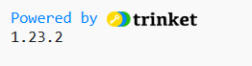
Output:

2. Convert List to 1D Array
Write a NumPy program to convert a list of numeric values into a one-dimensional NumPy array.
Solution:
Code:
import numpy as np
l = [12.23, 13.32, 100, 36.32]
print("Original List:", l)
a = np.array(l)
print("One-dimensional NumPy array: ", a)

Output: 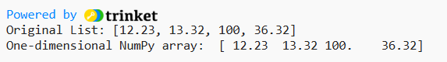
3. Create 3x3 Matrix (2?10)
Write a NumPy program to create a 3x3 matrix with values ranging from 2 to 10.
Solution:
Code:
import numpy as np
a = np.random.randint(2,10,size=[3,3]);
print(a)

Output:
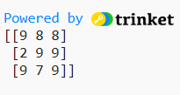
4. Null Vector (10) & Update Sixth Value
Write a NumPy program to create a null vector of size 10 and update the sixth value to 11.
Solution:
Code:
import numpy as np
a = np.zeros([10]);
print(a);
a[6]= 11;
print("\nUpdate sixth value to 11");
print(a);

Output:
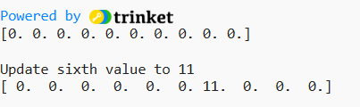
5. Array from 12 to 38
Write a NumPy program to create an array with values ranging from 12 to 38.
Solution:
Code:
import numpy as np
a = np.arange(12, 38)
print(a);

Output:
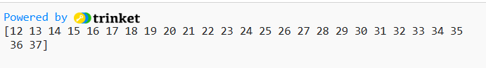
6. Reverse Array
Write a NumPy program to reverse an array (the first element becomes the last).
Solution:
Code:
import numpy as np
a = np.arange(12, 38)
print("Original array:\n",a);
a = a[::-1];
print("Reverse array:\n",a);

Output:
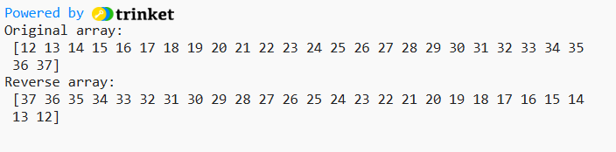

7. Convert Array to Float Type
Write a NumPy program to convert an array to a floating type.
Solution:
Code:
import numpy as np
a = [1, 2, 3, 4]
print("Original array")
print(a)
a = np.asfarray(a)
print("Array converted to a float type:")
print(a)

Output:
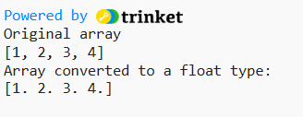

8. 2D Array (Border 1, Inside 0)
Write a NumPy program to create a 2D array with 1 on the border and 0 inside.
Solution:
Code:
import numpy as np
a = np.ones((5, 5))
print("Original array:")
print(a)
print("1 on the border and 0 inside in the array")
a[1:-1, 1:-1] = 0
print(a)

Output:
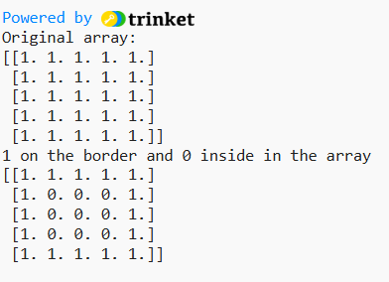

9. Add Border to Array (0s)
Write a NumPy program to add a border (filled with 0's) around an existing array.
Solution:
Code:
import numpy as np
a = np.ones((3, 3))
print("Original array:")
print(a)
print("0 on the border and 1 inside in the array");
a = np.pad(a, pad_width=1, mode='constant', constant_values=0)
print(a)

Output:
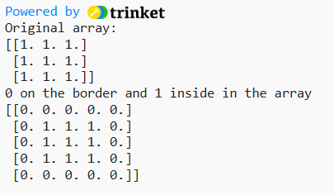

10. 8x8 Checkerboard Pattern
Write a NumPy program to create an 8x8 matrix and fill it with a checkerboard pattern.
Solution:
Code:
import numpy as np
a = np.zeros((8, 8), dtype=int);
a[1::2, ::2] = 1;
a[::2, 1::2] = 1;
print("Checkerboard pattern:");
print(a);

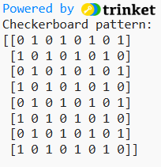
Output:

NumPy Mathematics Exercises, Practice, Solution

1. Element-wise Arithmetic Operations
Write a NumPy program to add, subtract, multiply, divide arguments element-wise.
Solution:
Code:
import numpy as np
print("Add:")
print(np.add(1.0, 4.0))
print("Subtract:")
print(np.subtract(1.0, 4.0))
print("Multiply:")
print(np.multiply(1.0, 4.0))
print("Divide:")
print(np.divide(1.0, 4.0))

Output:
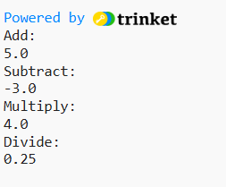

2. Log-Sum-Exp Computation
Write a NumPy program to compute logarithm of the sum of exponentiations of the inputs, sum of exponentiations of the inputs in base-2.
Solution:
Code:
import numpy as np
l1 = np.log(1e-50)
l2 = np.log(2.5e-50)
print("Logarithm of the sum of exponentiations:")
print(np.logaddexp(l1, l2))
print("Logarithm of the sum of exponentiations of the inputs in base-2:")
print(np.logaddexp2(l1, l2)) volume of a sphere with radius six is: ", volume)

Output:
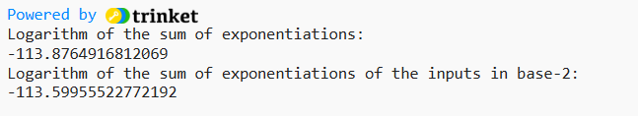

3. True Division of Array Inputs
Write a NumPy program to get true division of the element-wise array inputs.
Solution:
Code:
import numpy as np
a = np.arange(10)
print("Original array:")
print(a)
print("Division of the array inputs, element-wise:")
print(np.true_divide(a, 3))

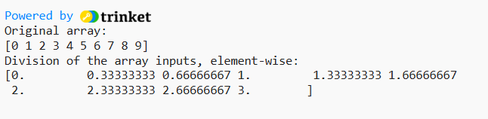
Output:

4. Floor Division (Largest Integer Less or Equal)
Write a NumPy program to get the largest integer smaller or equal to the division of the inputs.
Solution:
Code:
import numpy as np
a = [1., 2., 3., 4.]
print("Original array:")
print(a)
print("Largest integer smaller or equal to the division of the inputs:")
print(np.floor_divide(a, 1.5))

Output:
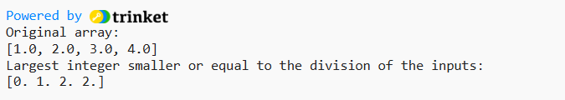

5. Element-wise Exponentiation
Write a NumPy program to get the powers of an array values element-wise.
Note: First array elements raised to powers from second array
Solution:
Code:
import numpy as np
a = np.arange(7)
print("Original array:")
print(a)
print("First array elements raised to powers from second array, element-wise:")
print(np.power(a, 3))

Output:
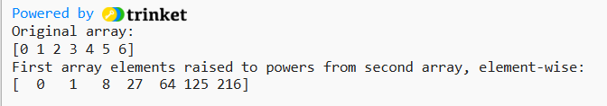

6. Element-wise Remainder (Modulo)
Write a NumPy program to get the element-wise remainder of an array of division.
Solution:
Code:
import numpy as np
a = np.arange(7)
print("Original array:")
print(a)
print("Element-wise remainder of division:")
print(np.remainder(a, 5))

Output:
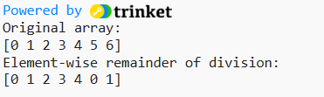

7. Element-wise Absolute Value
Write a NumPy program to calculate the absolute value element-wise.
Solution:
Code:
import numpy as np
a = np.array([-10.2, 122.2, .20])
print("Original array:")
print(a)
print("Element-wise absolute value:")
print(np.absolute(a))

Output:
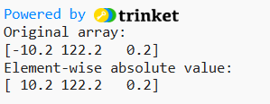

8. Rounding to Given Decimals
Write a NumPy program to round array elements to the given number of decimals.
Solution:
Code:
import numpy as np
a = np.round([1.45, 1.50, 1.55])
print(a)
a = np.round([0.28, .50, .64], decimals=1)
print(a)
a = np.round([.5, 1.5, 2.5, 3.5, 4.5])
print(a)

Output:
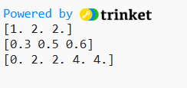

9. Nearest Integer Rounding
Write a NumPy program to round elements of the array to the nearest integer.
Solution:
Code:
import numpy as np
a = np.array([-.7, -1.5, -1.7, 0.3, 1.5, 1.8, 2.0])
print("Original array:")
print(a)
a = np.rint(a)
print("Round elements of the array to the nearest integer:")
print(a)

Output:
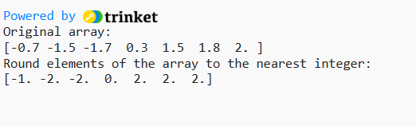

10. Floor, Ceiling, and Truncation
Write a NumPy program to get the floor, ceiling and truncated values of the elements of a numpy array.
Solution:
Code:
import numpy as np
a = np.array([-1.6, -1.5, -0.3, 0.1, 1.4, 1.8, 2.0])
print("Original array:")
print(a)
print("Floor values of the above array elements:")
print(np.floor(a))
print("Ceil values of the above array elements:")
print(np.ceil(a))
print("Truncated values of the above array elements:")
print(np.trunc(a))

Output:

